Running Spark On AWS EMR

Let’s take a stab at running Spark through AWS EMR (Elastic Map Reduce), an Amazon service that enables us to provision a Spark cluster of machines and run jobs on Big Data. Furthermore, we will leverage Jupyter Notebooks to actually interact with our spark jobs, although it is worth noting that we also have the ability to SSH into our cluster and run scripts that way as well.

**Creating a Cluster on AWS EMR** **1**

Provisioning the Hardware 2

Configuring Jupyter Notebook 5

**Running Spark Cluster Tasks via Jupyter Notebook** **7**

Basic Notebook Operations and Kernel 7

Loading Your Data Into S3 10

Loading Your Data To EMR From S3 13

Cleaning up 15

# 

# 

# 

# 

# 

# 

# 

# 

# 

# Creating a Cluster on AWS EMR

First, we begin by provisioning a basic “cluster” - a single master node and two worker nodes in EMR. This will provide us with the hardware necessary to run our Spark jobs.

## Provisioning the Hardware

Begin by logging in to AWS and search for EMR in the homepage.

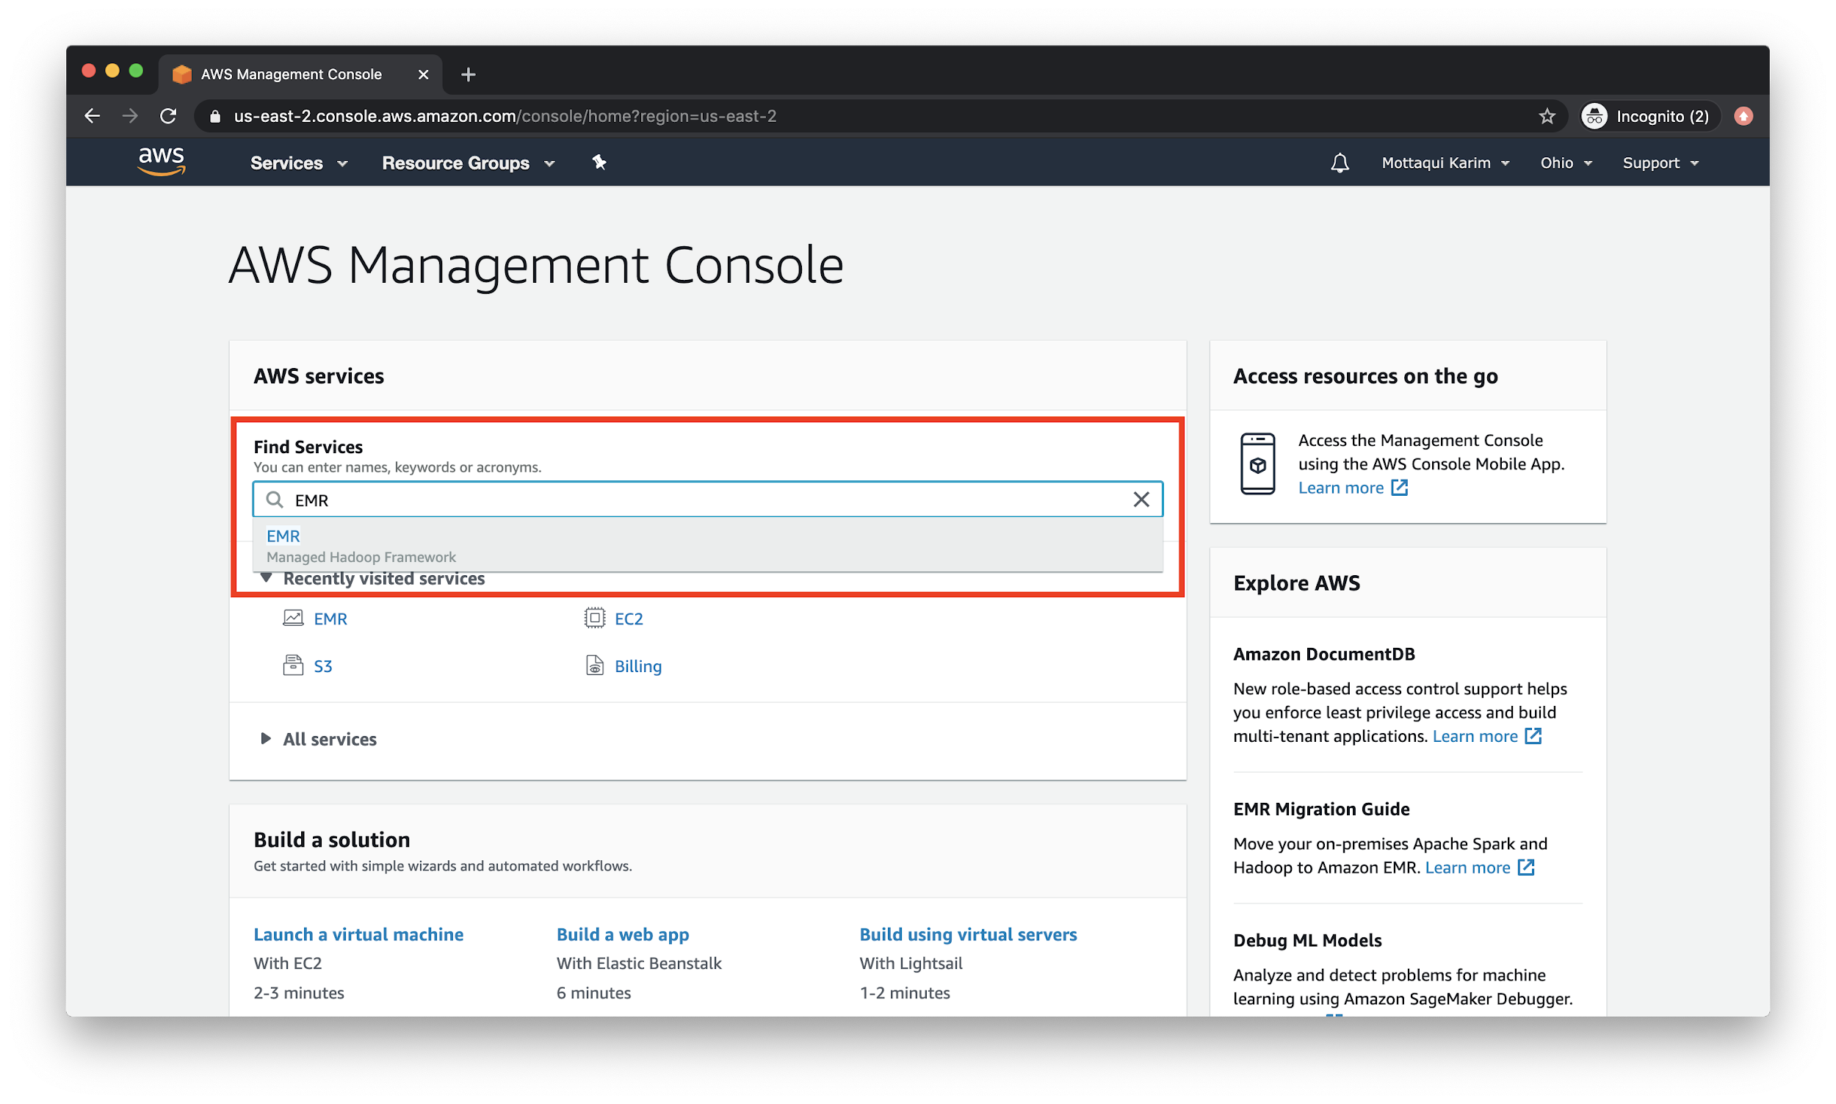

Click on the **Create Cluster** button and then go to **Advanced Options**.

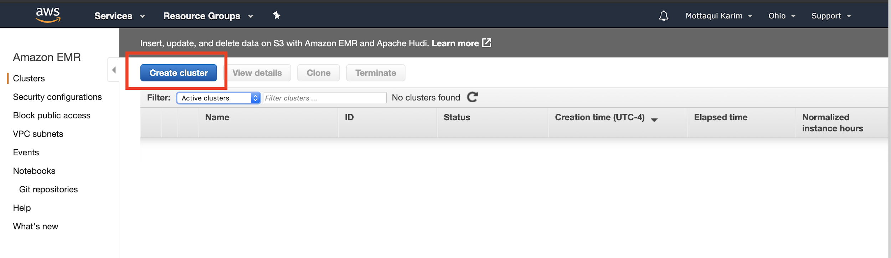

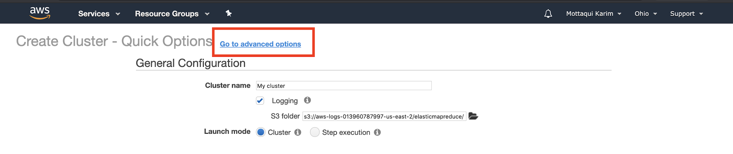

Ensure the following selections are made. Specifically, you want to pick **emr-5.29.0** for the **Release** option. Also, ensure that **Spark** is selected.

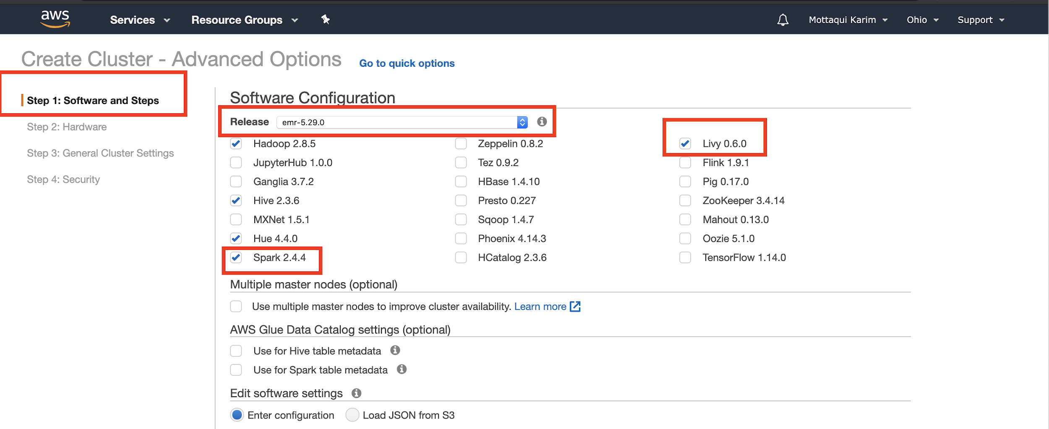

Then, hit **Next** to go to **Step 2.**

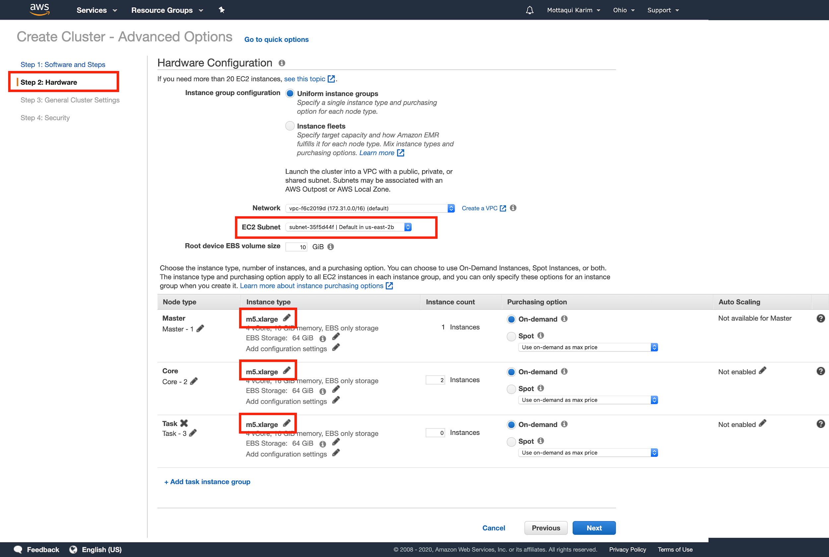

You shouldn’t have to make any changes here - however, just ensure that your **EC2 Subnet** is configured correctly and that your instance types are **m5.xlarge**. Then, hit **Next** to go to **Step 3**.

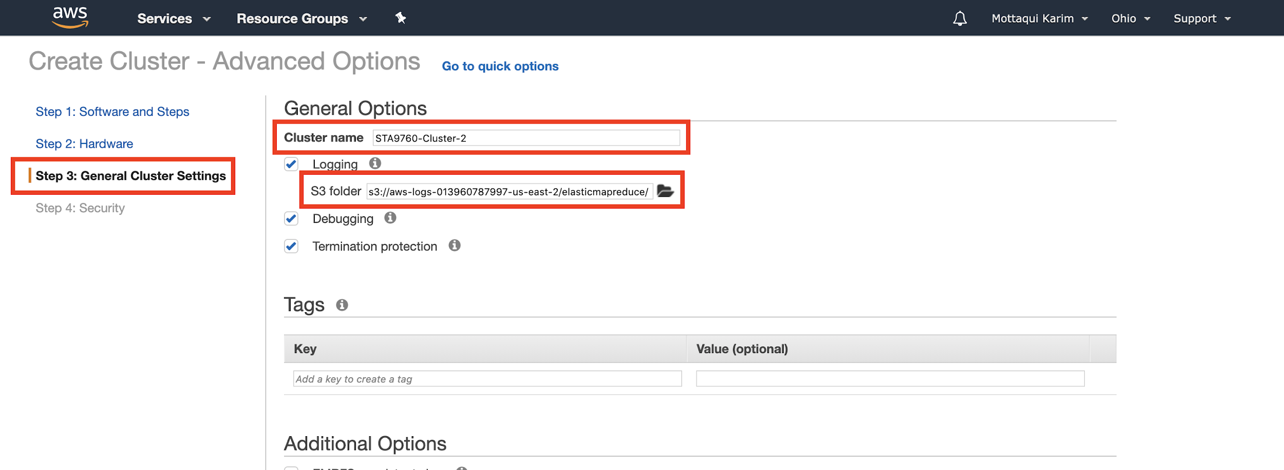

Give your cluster a meaningful name and take note of the **S3 file path**, as that is where your Jupyter notebooks and other artifacts will be saved. You don’t have to do anything with this s3 bucket yet but you might want to save the path into a notepad or something.

Then, hit **Next** to go to **Step 4**.

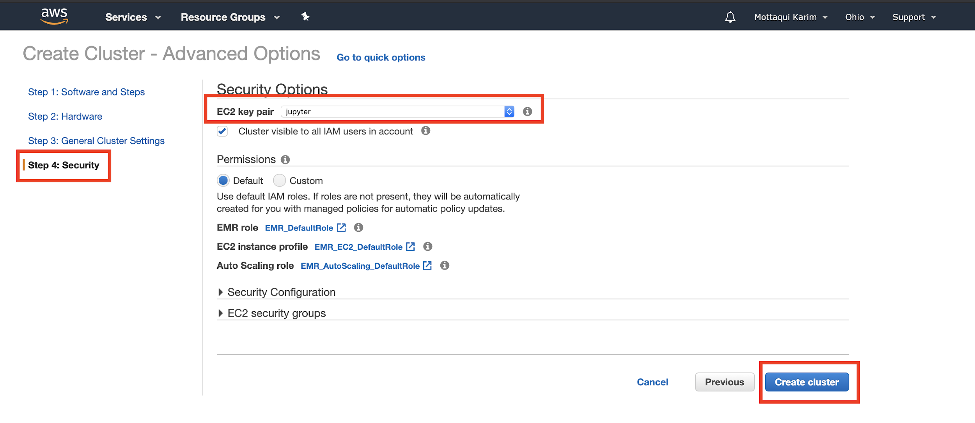

For **EC2 key pair**, select a key **for which you already have a .pem file saved**. Remember, these files are what we generate whenever we build a new EC2 instance. Before selecting a key pair, ensure you know where the corresponding **.pem** file is stored on your local machine. This is for the case when you might want to SSH into your cluster for processing or running scripts. (Technically for this lesson you won’t need this key file - so if you don’t have the pem file handy, no reason to restart this process).

Then, click **Create cluster** to spin up your hardware!

If it all worked as expected, you should see a screen similar to this:

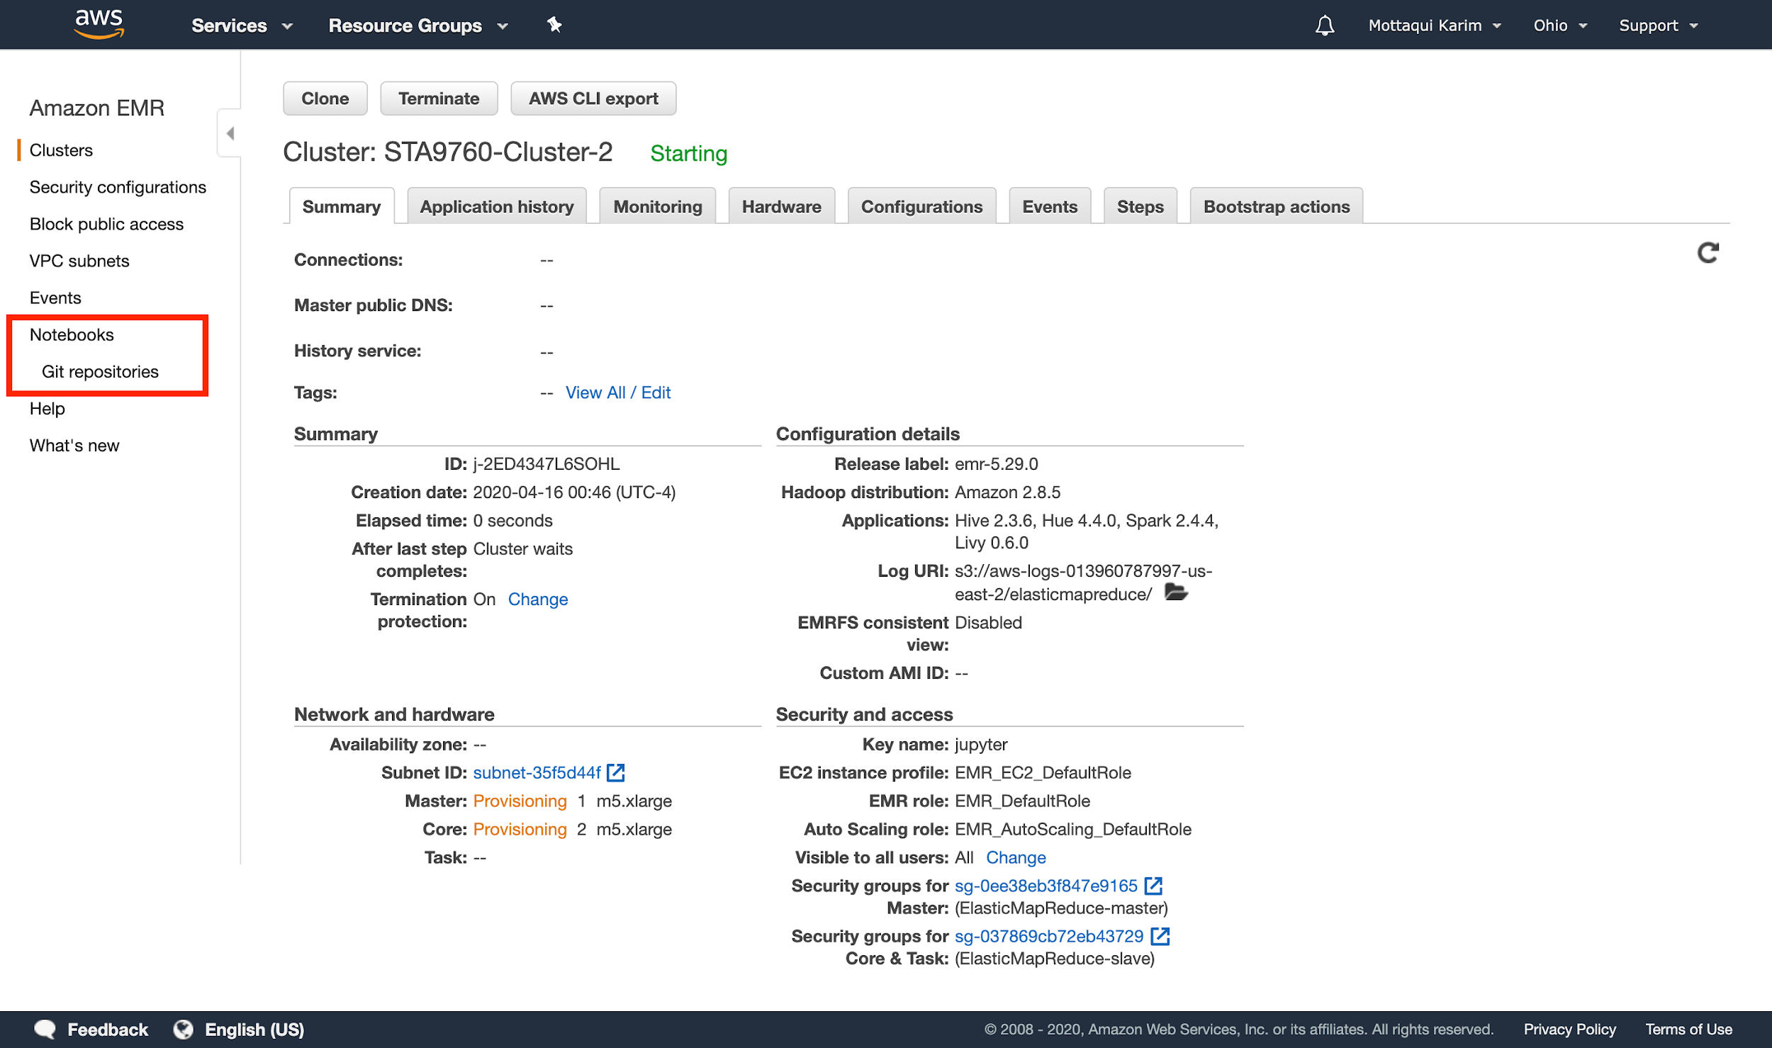

## Configuring Jupyter Notebook

Click on the **Notebook** option on the left menu. Hit **Create Notebook** and choose the cluster you just provisioned.

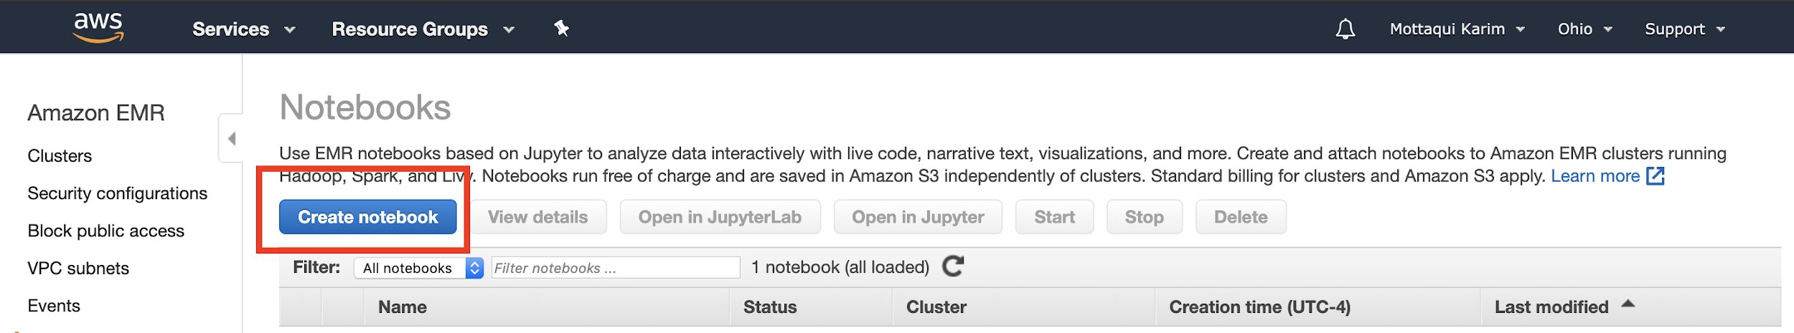

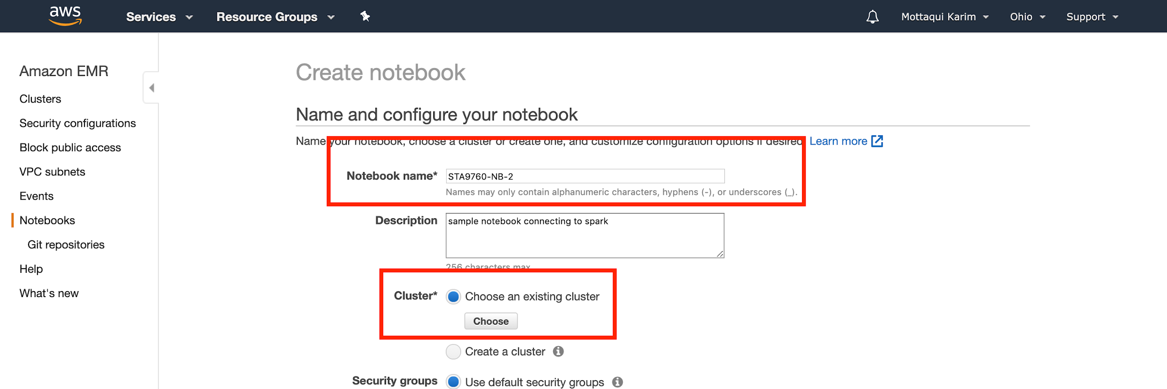

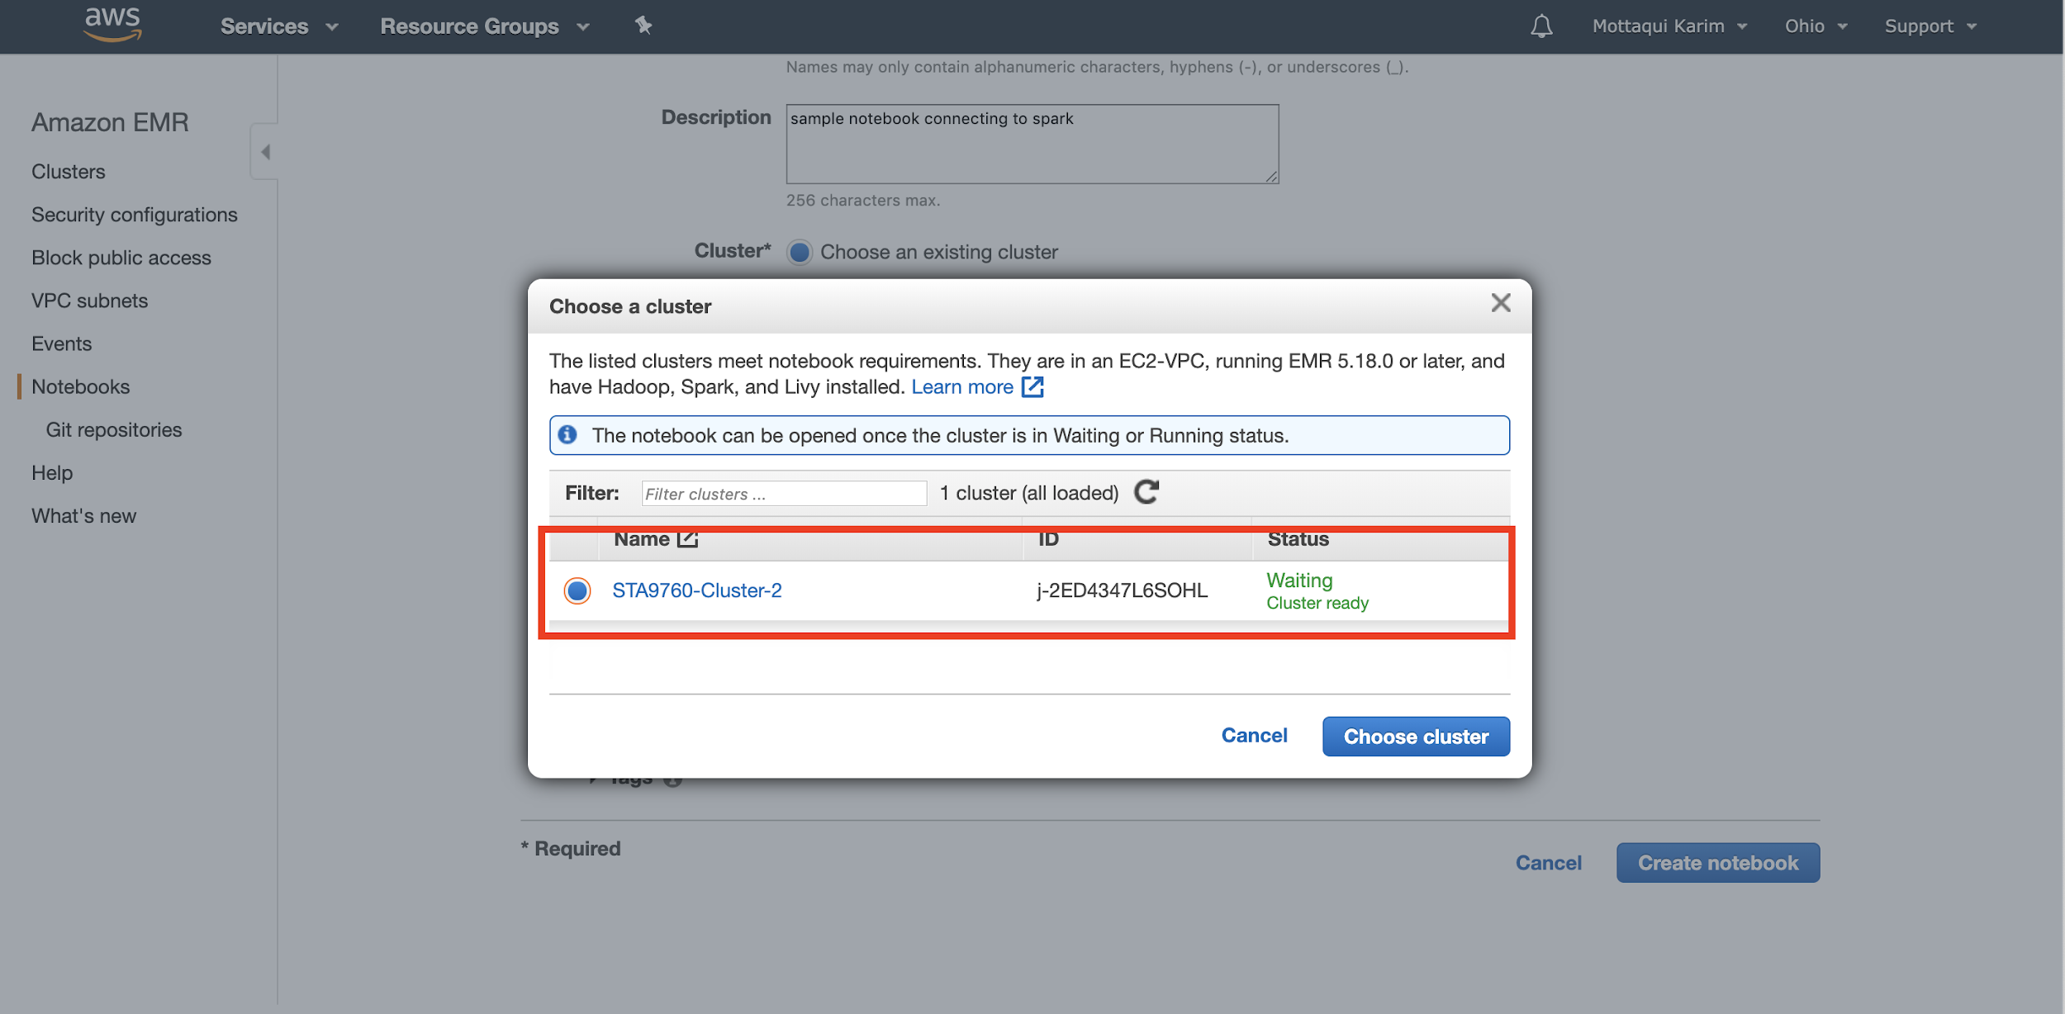

After choosing a cluster, click **Create Notebook**. It should take a minute, but once the buttons are available, click **Open in Jupyter** to get started!

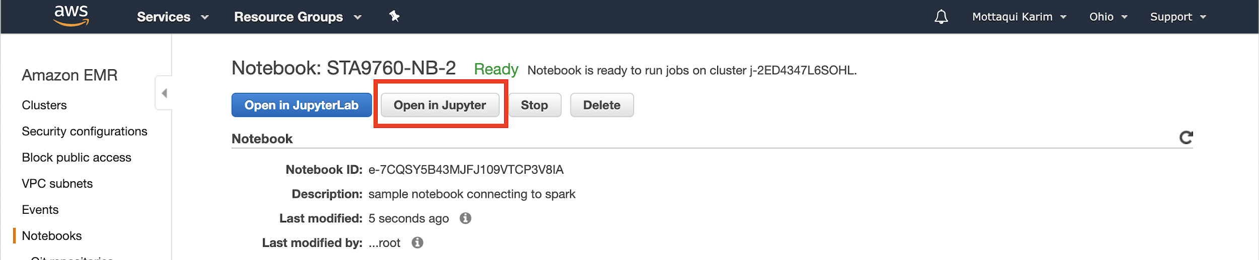

**NOTE: BE SURE TO STOP YOUR NOTEBOOK AND SPIN DOWN YOUR CLUSTER AFTER YOU ARE DONE TO AVOID SURPRISE (AND POTENTIALLY EXPENSIVE) MONTHLY CHARGES!**

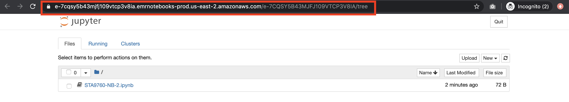

For as long as your cluster and notebook is running, you should be able to access your Jupyter instance via the URL indicated above. Click into your **ipynb** file and let’s begin with a short analysis.

# 

# Running Spark Cluster Tasks via Jupyter Notebook

Let’s explore how we might be able to run Spark jobs via Jupyter Notebook connected to our cluster.

## Basic Notebook Operations and Kernel

First thing’s first, make sure to choose the **PySpark** kernel before doing anything else.

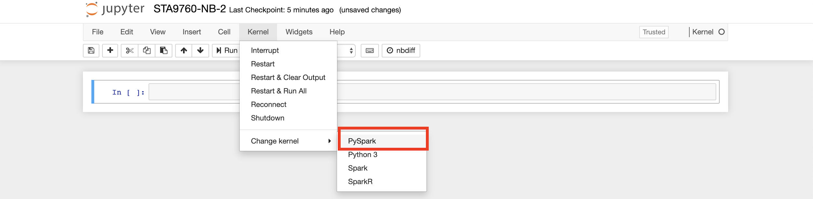

To ensure everything is working as expected, type the following into the first cell of your notebook.

|  |
| --- |
| %%info |

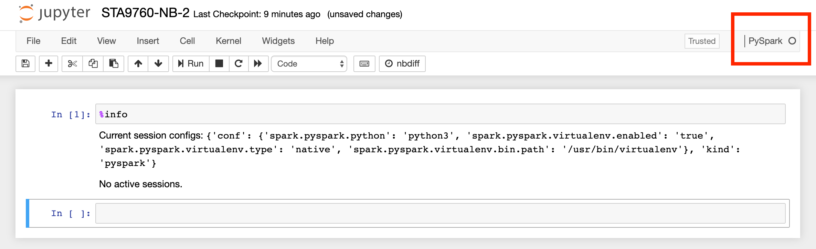

If you get a message similar to that, you should be good to go!

Viewing and installing packages on the cluster via the notebook requires some special coding:

|  |
| --- |
| sc.list_packages() |

This will print out all the “out-of-the-box” packages available to your notebook environment.

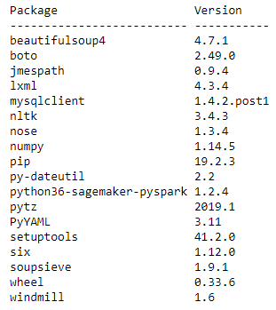

(There are more, I just cropped it - run the command on your notebook to view them all). To install a package, run:

|  |
| --- |
| sc.install_pypi_package("pandas==1.0.3") |

You can find the version of the package by visiting [**pypi**](https://pypi.org/project/pandas/). This generally will result in something like:

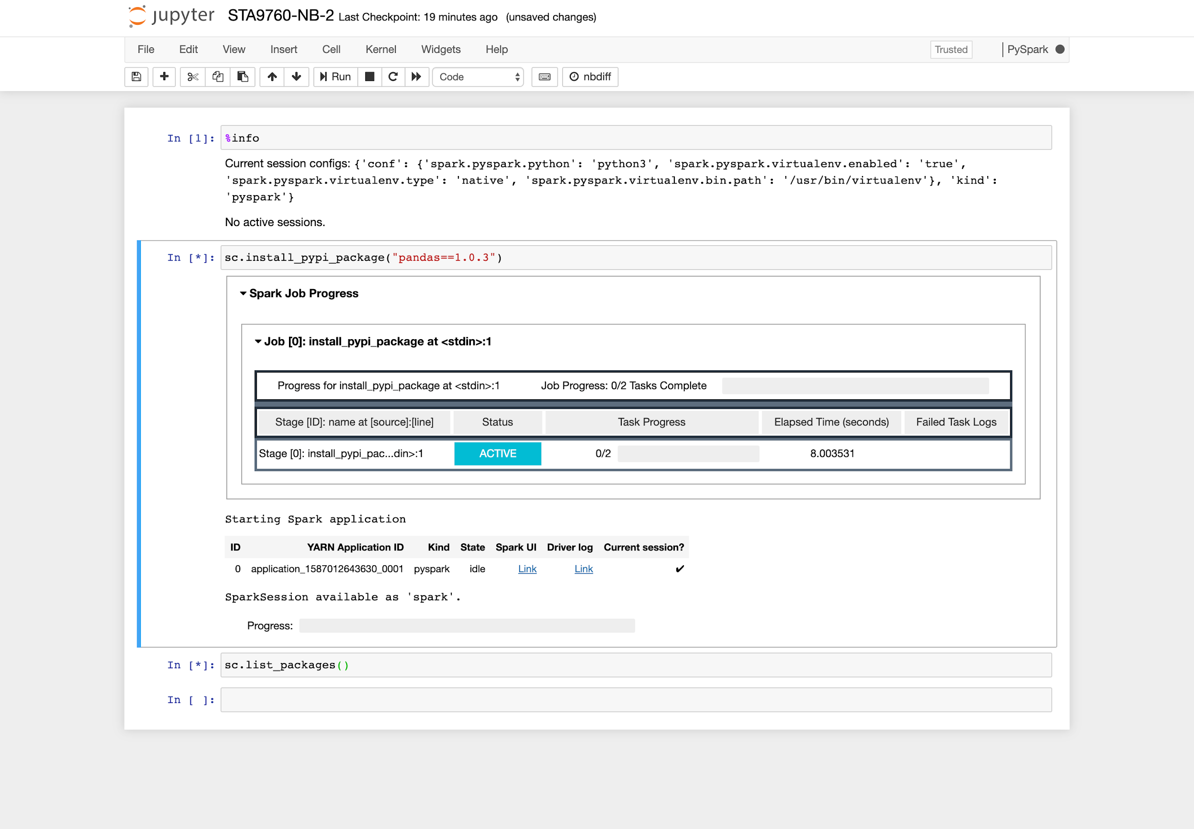

Once the job is complete, you can view a full record like so:

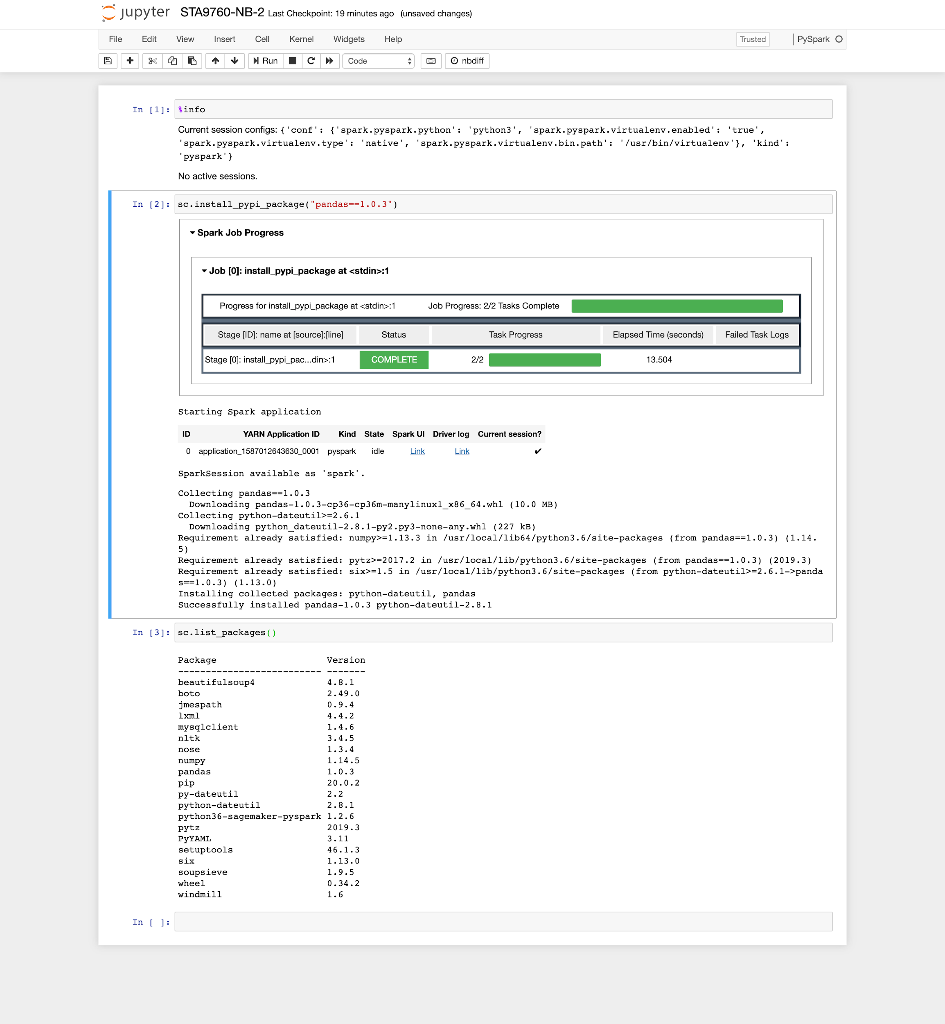

And finally, re-running the **sc.list_packages()** will result in

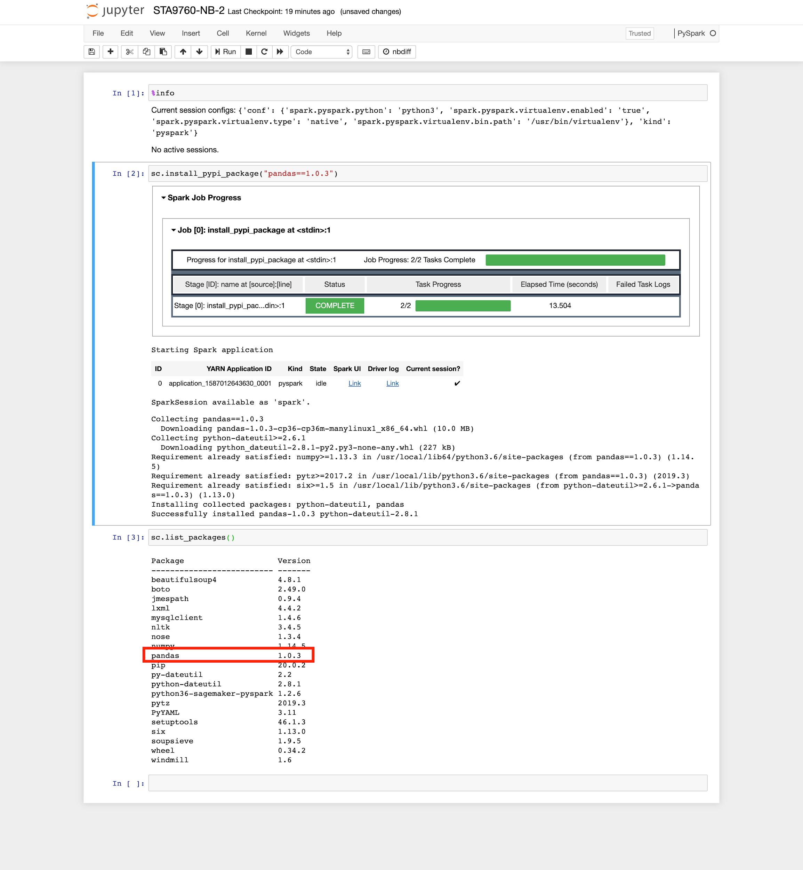

As you can see, **pandas** has been added to the environment and should now be accessible. (While you’re at it, be sure to also install matplotlib):

|  |
| --- |
| sc.install_pypi_package("matplotlib==3.2.1") |

## Loading Your Data Into S3

The real power of using an EMR cluster is that we *finally* can rely on HDFS to access our data. AWS supports pulling in Big Data from [**s3 buckets**](https://aws.amazon.com/s3/) - their equivalent of HDFS - into our cluster. Let’s revisit our [**CitiBike dataset,**](https://s3.amazonaws.com/tripdata/index.html) but this time let’s pull a “real” sample of [**over 170Mb for analysis**](https://s3.amazonaws.com/tripdata/201307-201402-citibike-tripdata.zip). (You can click on this link to download this dataset).

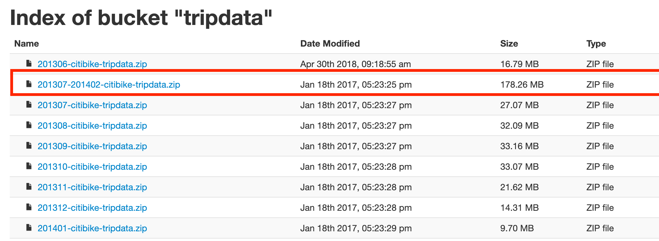

Now, let’s first create an **s3 bucket**, which is essentially a folder that can hold data. From **AWS** homepage, type in **S3** and then click on **Create Bucket.**

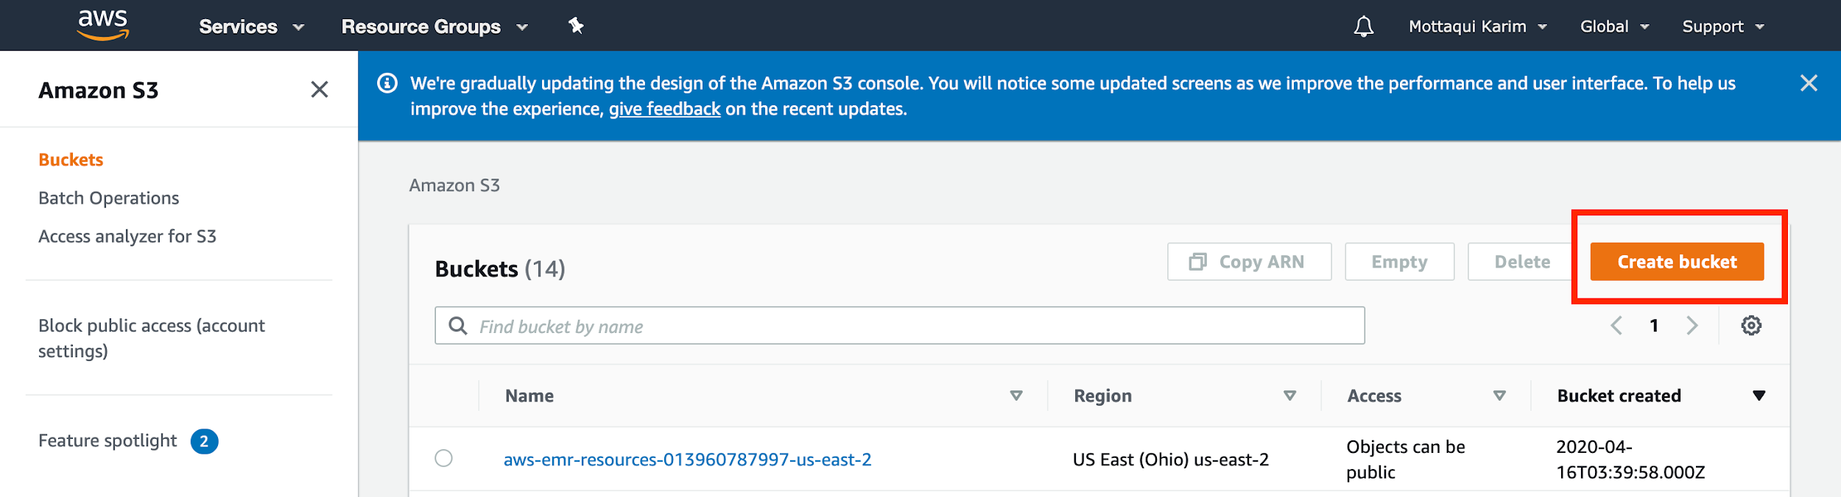

All you have to do after this step is specify a bucket name - generally, you want your bucket name to lack spaces and be delimited only by dashes or underscores. Then, hit **Create Bucket.**

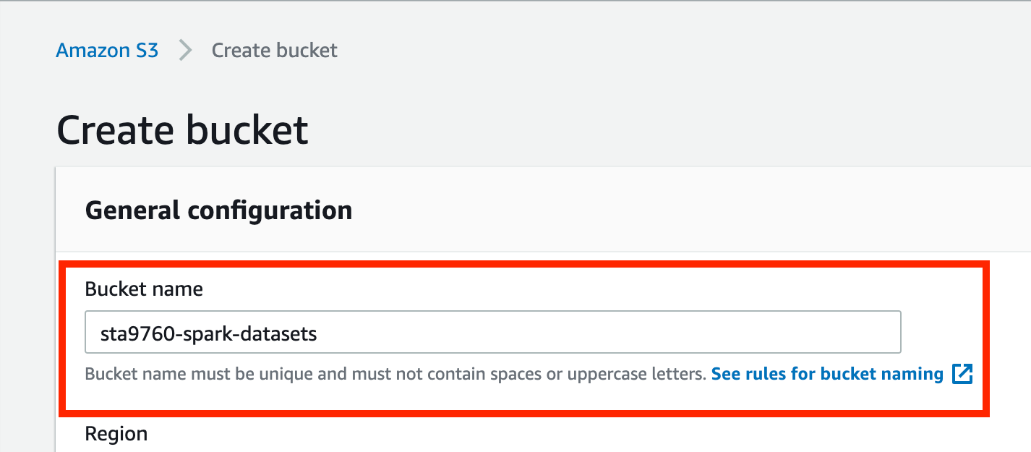

Once you hit **Create Bucket**, you will be redirected to the **S3** landing page but now you should see the bucket you just created available in the list.

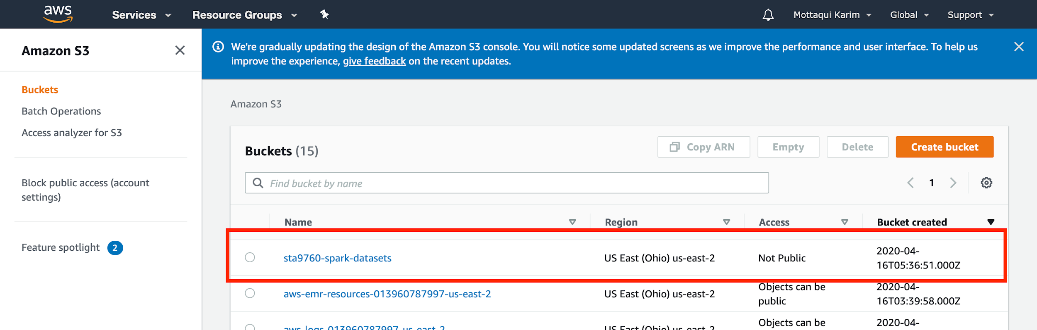

Click into that bucket and you should be redirected to the bucket landing page. Hit **Upload** to upload the CSV from your CitiBike dataset to S3.

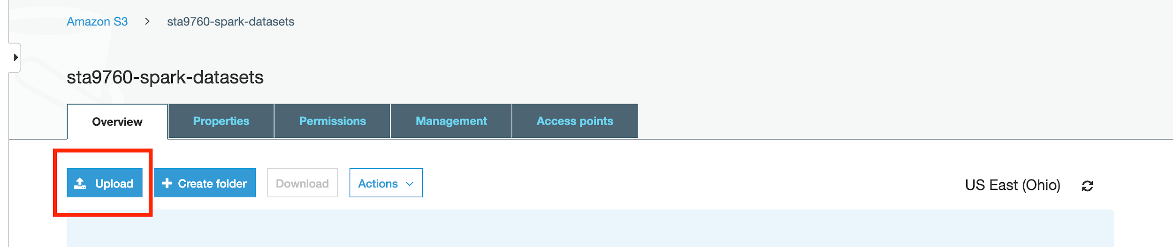

Once you upload the file via the dialog, hit the **Upload** button - no need to hit **Next** (which is if you want to additionally configure accessibility and other features of your particular file). In this case, there is no need for this.

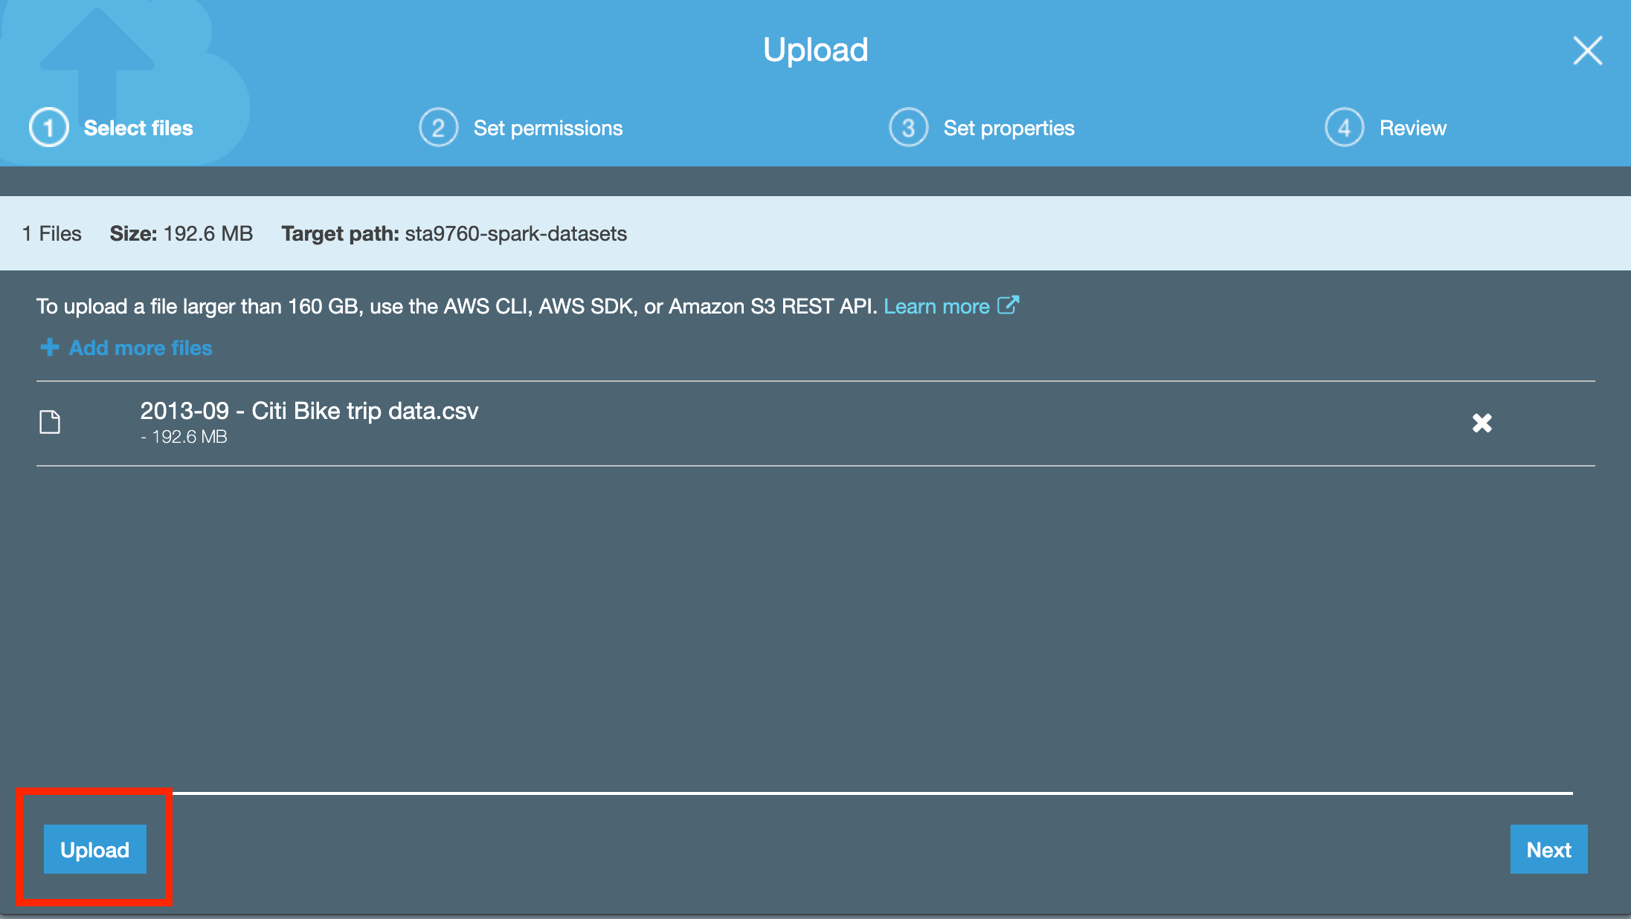

Also note that I am using the **2013-09 - Citi Bike trip data.csv** file. It really ought to have been renamed such that the spaces are removed, but it will work regardless (just ugly to read url encoded in the browser).

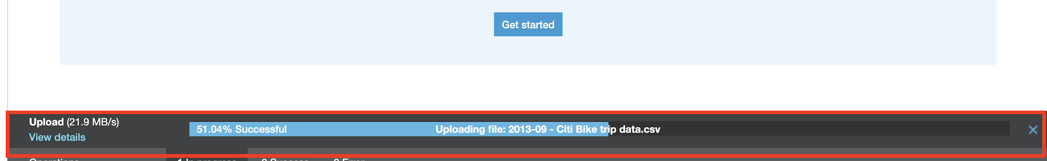

Once completed, make note of your **bucket name** and **file name**.

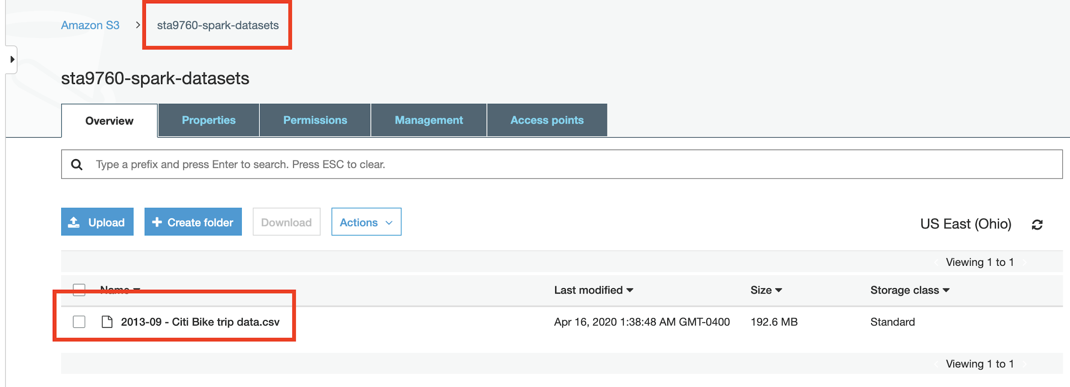

I highlighted mine in red. We can create an **s3** url from these two data points, for me it would be: **s3://sta9760-spark-datasets/2013-09 - Citi Bike trip data.csv**

## Loading Your Data To EMR From S3

Now, let’s go back to our notebook and since our data is available in **S3**, we can run the following:

|  |
| --- |
| df = spark.read.csv('s3://sta9760-spark-datasets/2013-09 - Citi Bike trip data.csv', header='true', inferSchema = **True**) |

This will tell spark to ingest the data into the cluster for processing. Note that about 200**Mb** of data was ingested in ~6s.

With Pandas, this would have taken forever - if at all!

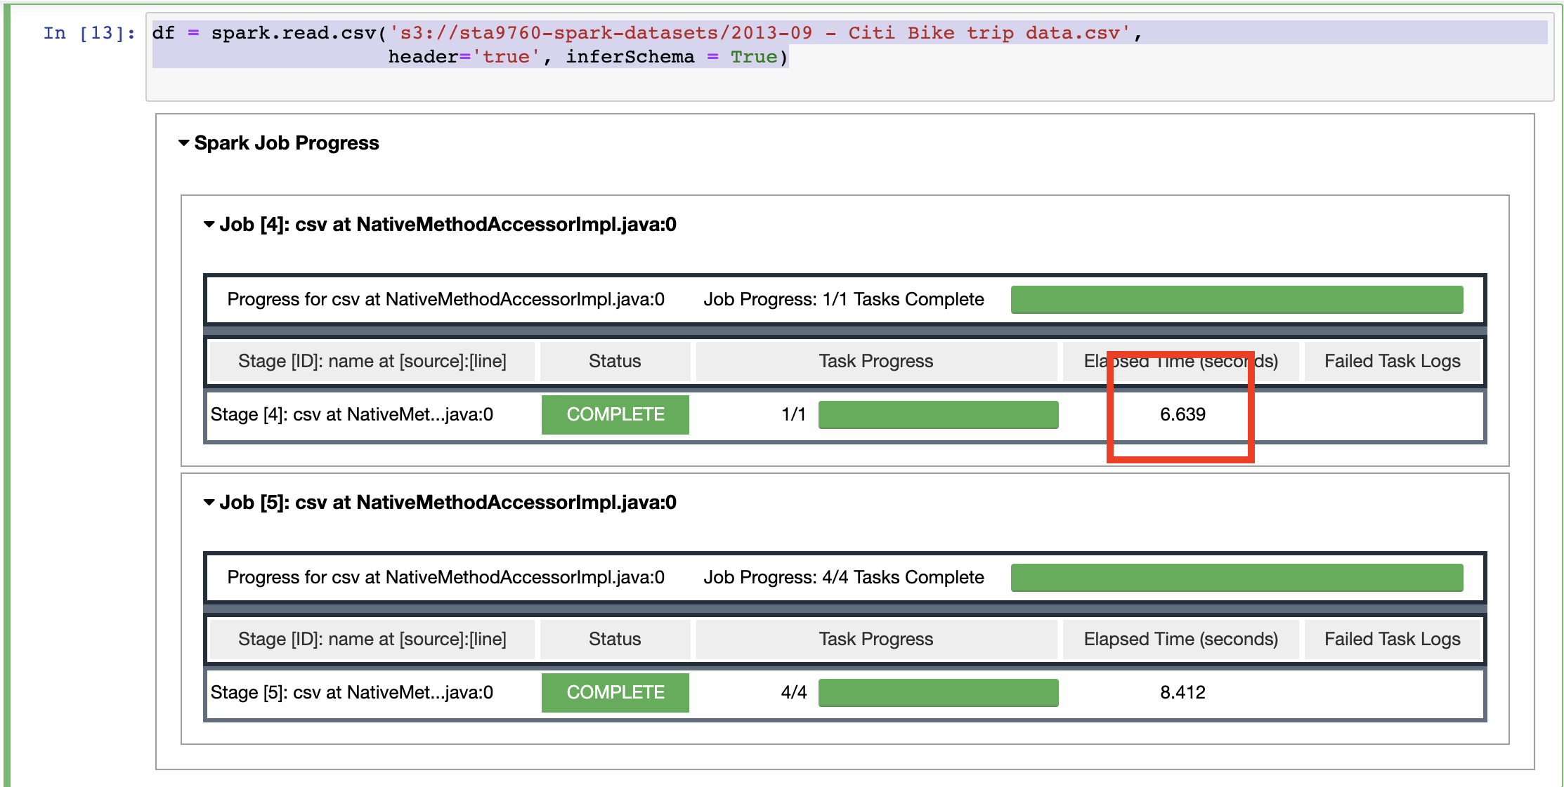

(Also note that globbing is supported in Spark - so we could have uploaded *all* of our CSV files from the dataset into s3 and if we had run:

|  |
| --- |
| df = spark.read.csv('s3://sta9760-spark-datasets/*.csv', header='true', inferSchema = **True**) |

Instead (notice the **\***) then *all* of the data would have been loaded into a single dataframe object in spark.

At this point, we can run dataframe methods (remember, this is the PySpark.dataframe, *not* pandas.dataframe) as per usual

|  |
| --- |
| # Total columns print(f'Total Columns: {len(df.dtypes)}')  print(f'Total Rows: {df.count():,}') df.printSchema() |

The output:

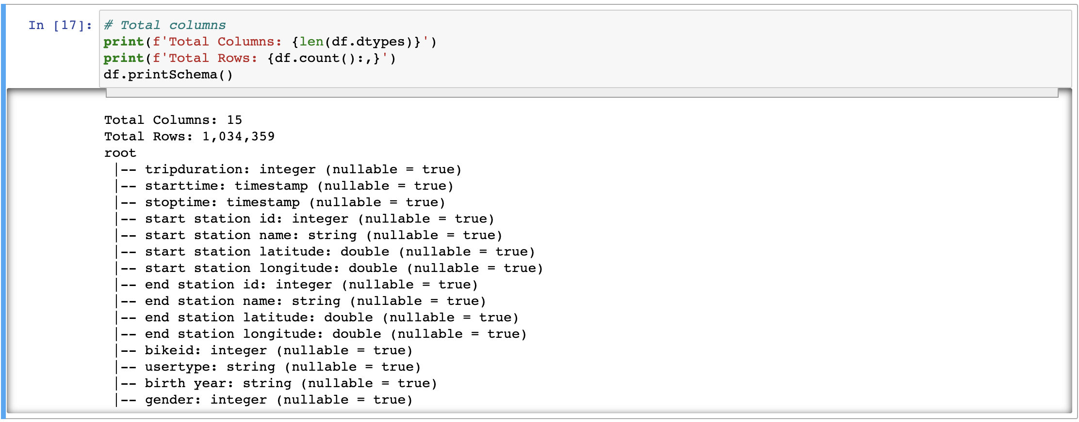

Over a million rows loaded in just a few seconds! To compare to last lecture, where we ran this on a single EC2:

|  |
| --- |
| df.createOrReplaceTempView('Citibike')  sqldf = spark.sql( ''' SELECT `end station name`, COUNT ( `end station name`) as most_popular_stations FROM Citibike GROUP BY `end station name` ORDER BY most_popular_stations DESC LIMIT 5 ''' )  sqldf.toPandas().plot.bar() |

(diagram below)

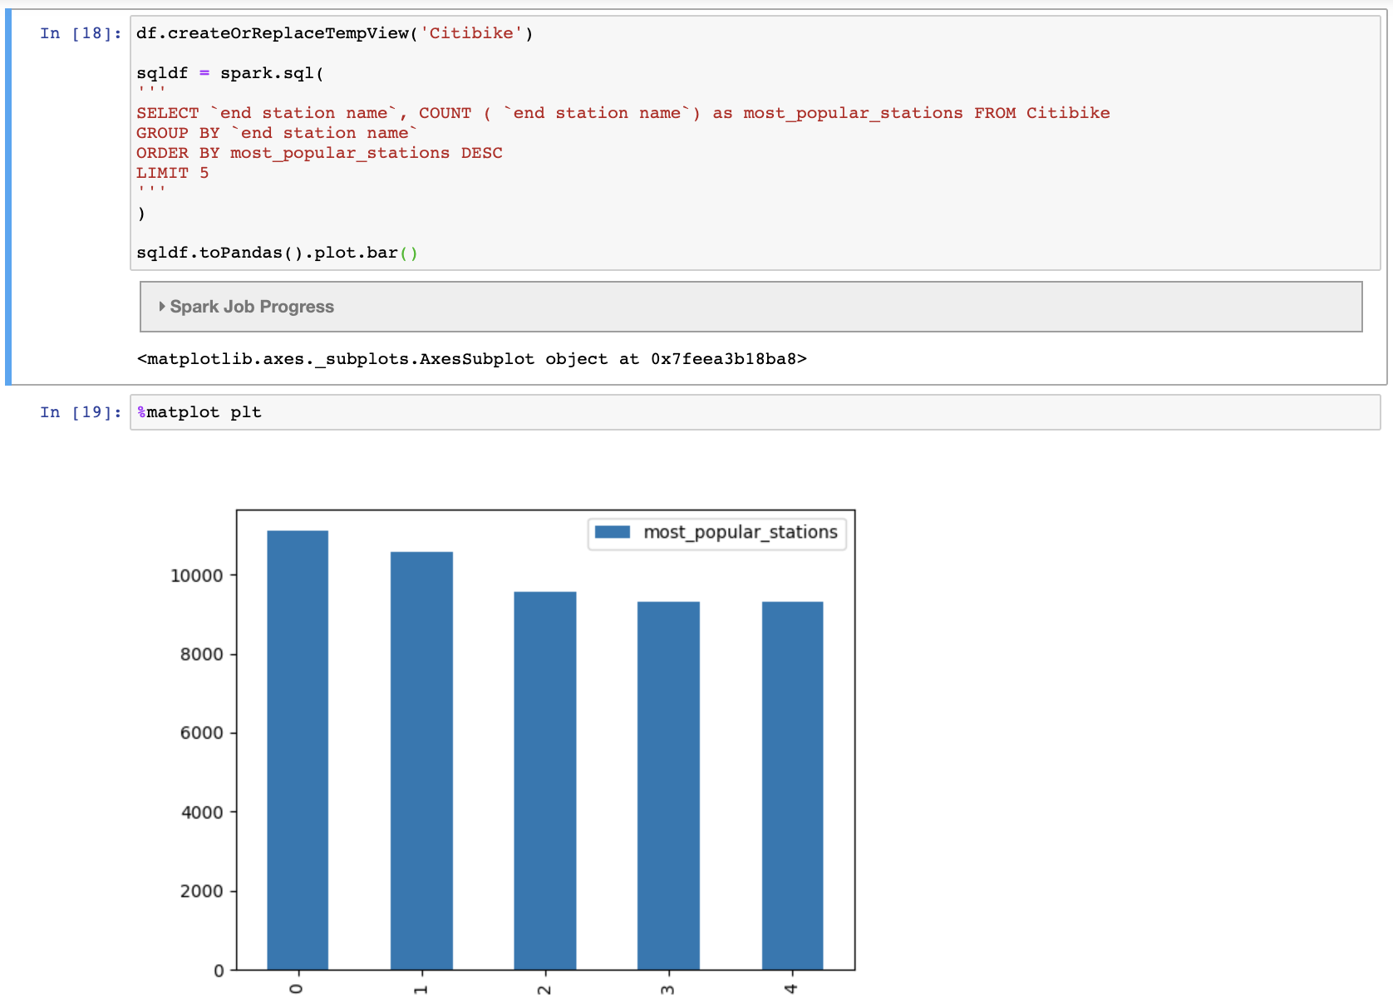

## Cleaning up

Once your analysis is complete, you want to shut down your notebook and cluster to save on costs. Return to the **Notebooks** landing page on AWS Console.

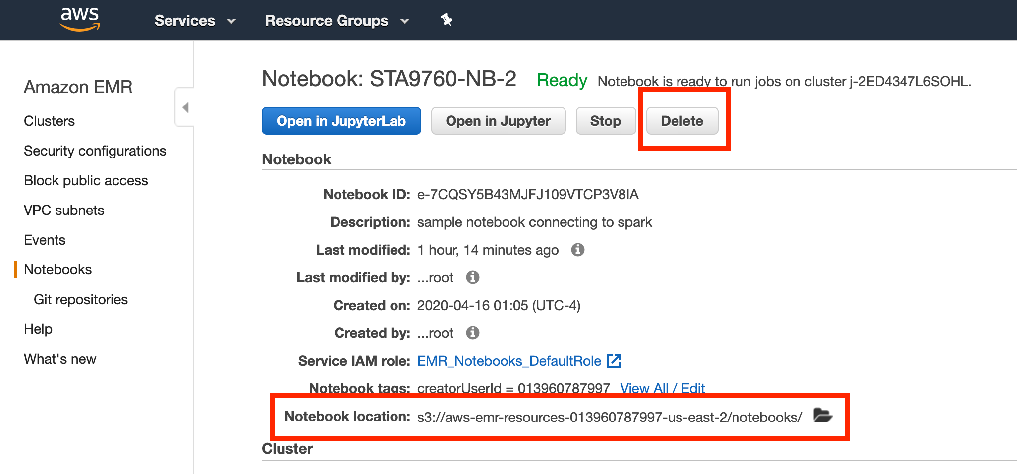

Take note of the **s3** **location** - you can find the resultant **ipynb** file there to download and share on github, etc. Hit the **Stop** button to spin down the notebook. Then,

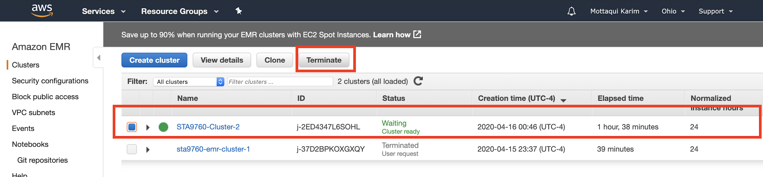

Select your running cluster and hit the **Terminate** button**.** You will get a prompt, confirm and then delete. Spinning down may take a few minutes. **Ensure that** both notebook and cluster have both been stopped.

If you return to your notebook tab, you will see that it is no longer accessible. There is no need to delete your s3 files unless you have literally petabtyes of data stored. It should be pennies, if at all, per month in terms of cost.